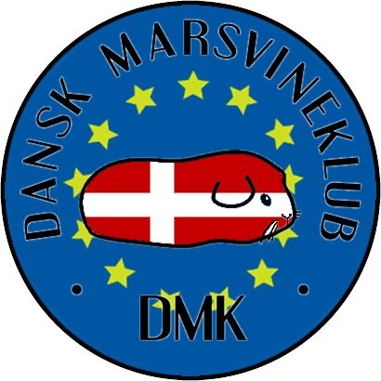
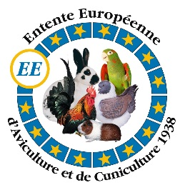
Entry form for the Breed Specific Show in Denmark November 18th-20th 2016.
Exhibitor information
First name
Last name
Adress
Country
Telephonenumber
Email adress
Name of your association/club

Fees and amount to be paid
Guinea pig entries à 7 €/guinea pig | X7€ | Total €
Registration fee (mandatory) à 12 €/exhibitor | 1 X12€ | Total € | 12
Sales cages à 3,5 €/cage | X3,5€ | Total €
Transit fee, 1 €/guinea pig in transit (or pay at arrival) | X1€ | Total €
Social dinner Saturday à 29 €/diner | X29€ | Total €
Breeders’ adverts in catalogue à 20 €/ ¼ page on A5 | X20€ | Total €
Total amount due |  | Total €

Guinea pig entries for the EE show
Name | C for collec-tion | Sex  (M/F) | Birth date ddmmyy | Breed /Category | Color and/or marking | Sales price (€)

Entries: Single exhibits OR
Collections: 4 exhibits of 1 breed and 1 colour to comprise both male and female exhibits.
E-class: breeds and/or colours, not yet standardised in the European standard (please note breed and write E after)
Example:
Guinea pig entries for the EE show
Name | C for collec-tion | Sex (M/F) | Birth date ddmmyy | Breed | Color and marking | Sales price (€)
Disney’s Mickey |  | M | 010116 | Nonself | Chocolate dutch
Olsen’s Bimse |  | M | 250316 | Alpaca | Tricolor | 20
Disney’s Minnie |  | F | 130815 | teddy | White RE
Disney’s Goofey |  | M | 070916 | Self E | Coffee
Disney’s Robin Hood | C | M | 050516 | Self | White DE
Disney’s Marion | C | F | 050516 | Self | White DE
Disney’s Peter Pan | C | M | 070816 | Self | White DE
Disney’s Pocahontas | C | F | 080816 | Self | White DE

Entry form for the special pet show sunday
Exhibitor name
Guinea pig’s name
Guinea pig’s sex
Guinea pig’s birthday |  | dd-mm-yy
Guinea pig’s origen |  | A |  |  |  | B
A = from your own breeding/Stud, B = bought from someone else
Petclass
(only one X please)
Veteran Pets (4-6 years) |  |  | Pets (from 3 months to 4 years) |  |  |  | Childrens pets (child under 15 years both owning and showing)

